**\*ER Diagram located below**

**Database Assumptions**

* OffenceCategoryID is unique
* An offence category can apply to >=1 offences
* OffenceID is unique
* An offence can only relate to 1 offence category
* A offence can apply to >=0 cases
* CaseID is unique
* A case can involve >=1 offences
* AttorneyID is unique
* LegalFirmID is unique
* An attorney can work for only 1 legal firm at a time
* A legal firm can employ >=1 attorneys at a time
* A case can only be taken on by 1 legal firm at a time
* A prisoner cannot represent themselves in court
* An attorney/legal firm can defend >=0 prisoners at a time
* CaseStatusID is unique
* A case can only have 1 status
* A case status can be applied >=0 cases
* A case can only pertain to 1 prisoner
* HearingID is unique
* A hearing can only take place on 1 date and time
* A hearing can only pertain to 1 case
* A case can involve >=1 hearings
* A hearing can only take place in 1 court
* CourtID is unique
* A court can only have 1 location
* A court can try >=1 prisoners
* A court can conduct >=0 hearings at a time
* PrisonerID is unique
* A prisoner can be tried in >=1 cases at a time
* StatePrisonID is unique
* A prisoner can serve time in >=1 state prisons
* A prison can contain >=0 prisoners at a time
* A prisoner can be admitted to only 1 prison at a time
* A prisoner can be admitted to a particular prison >=0 times
* A prisoner can be admitted to prison >=1 times
* A prisoner can be release from prison >=0 times
* ReleaseStatusID is unique
* A release status can be applied to >=0 prisoners
* A prisoner's ReleaseDate can be NULL
* On any particular date >=0 prisoner can be admitted to prison
* On any particular date >=0 prisoner can be released from prison

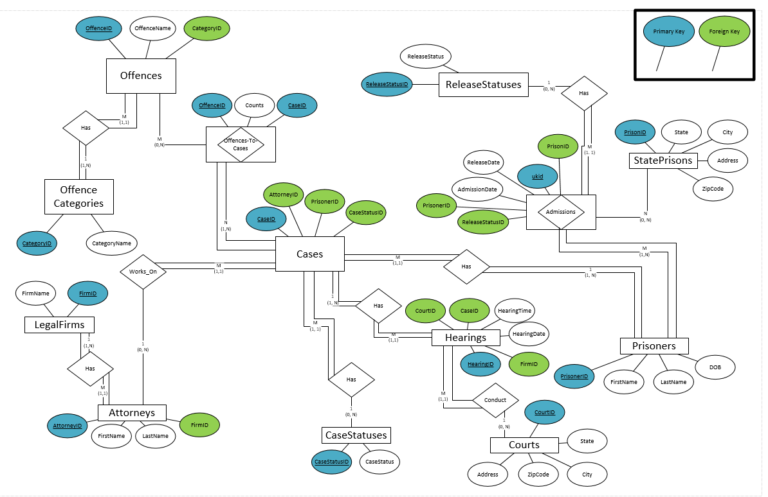**ER Diagram**